# **Worst to First – 2017 Dodge Dynasty Champion Jen Hayek**

Congratulations to Jen Hayek on capturing her first ever Dodge Dynasty League Championship! A year after finishing last in both record and points, Jen raced out to a 7-0 start, clinching her first division crown by week 10, pacing the league with a 10-3 record, and shattering the dynasty record for number of Christmas cookies baked. Jen got great returns out of picks like Leonard Fournette, Travis Kelce, and Drew Brees to fill out a strong lineup led by a resurgent year from Dynasty MVP/Playoff MVP/Living Legend Todd “Todd todd todd” Gurley. In the post-season, Jen survived her bye and thumped a resilient Brian Kenderes squad 98-68, who after inheriting a seemingly underwhelming roster successfully parlayed it all the way to a 3rd place payout and a new house in Strongsville.

Pour one out for her title game opponent Dave Nickelsen. This season he augmented an already fearsome lineup with marquee additions like Kareem Hunt, Carson Wentz, and Baby Nickelsen 2: Electric Boogaloo (in theaters June 2018). Dave led the league in points by a mile, and annihilated his happy-to-be-here-oh-shit-never-mind-get-me-outta-here round 2 opponent George Hawke 138-78 to reach the finals. After a number of playoff appearances cruelly ended by the fickle hand of dynasty fate, this finally looked like it was going to be Dave’s year. Advantage fickle hand of fate however, as Dave fell 129-91 and has now come up short in three different dynasty title contests, being blitzed by an average of 135 points against in his past two. Tough break Dave, I feel your pain. But with Gurley on Jen’s side everyone else’s fate was sealed, as he closed out the year in unprecedentedly dominant fashion (103 points in the final three weeks alone) – making sure Jen won like a [Gurley] girl.

Thanks to all for another wild dynasty season, and congrats again Jen for registering your name* on the Dodge Dynasty League Championship trophy!

* For trophy nameplate purposes, Jen Hayek’s preferred first name spelling of “George” will be used. (Well it was worth a shot)

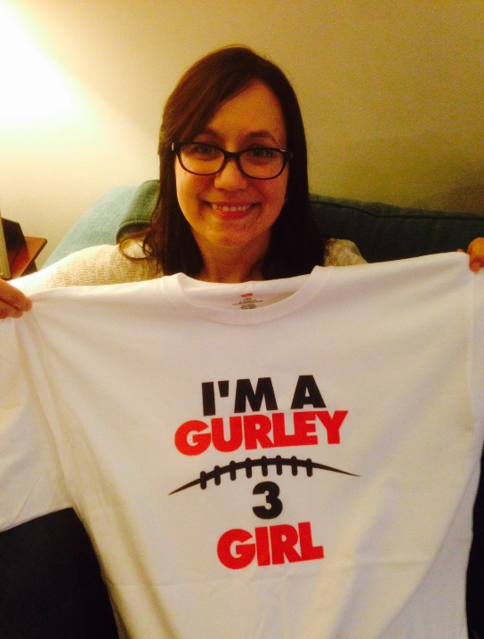

# **2017 Dodge Dynasty Awards**

**Dodge Dynasty MVP**

Winner: Todd Gurley – Jen

Runners-up: Antonio Brown – Brian; Le’Veon Bell – Jay; DeAndre Hopkins – Dave

**Playoff MVP**

Winner: Todd Gurley – Jen

Runners-up: Kareem Hunt – Dave; LeSean McCoy – Dave

**Pickup of the Year**

Winner: Carson Wentz – Dave

Runners-up: Alex Collins – Meat; Dion Lewis – Jeremiah; Marvin Jones – Dave; Robby Anderson – Steve

**Sleeper of the Year**

Playing for the team that drafted them

Winner: Alvin Kamara – George

Runners-up: Adam Thielen – Meat; Travis Kelce – Jen

**Bust of the Year**

Non-Injury

Winner: Jordy Nelson – Pohlmann

Runners-up: Jay Ajayi – Meat; Amari Cooper – Joe

**Rookie of the Year**

Winner: Kareem Hunt – Dave

Runners-up: Alvin Kamara – George; Leonard Fournette – Jen; Christian McCaffrey - Jay

Honorable Mention: Deshaun Watson – Jay

**Comeback Player of the Year**

Winner: Marshawn Lynch – Brian

Runners-up: Keenan Allen – George; Rob Gronkowski – Dave; DeAndre Hopkins – Dave; Todd Gurley - Jen

**Bitcoin® Breakout Player of the Year**

Non-Rookie

Winner: Tyreek Hill – Joe

Runners-up: Carson Wentz – Dave; Mark Ingram – Steve; Adam Thielen - Meat; Russell Wilson – Jay

**Dodge Dynasty Owner of the Year**

Winner: Dave Nickelsen

Runners-up: Jen Hayek; Brian Kenderes; Steve Miller

**Jordan Reed Lifetime Achievement Award**

(aka Fragile Freddie Award)

Winner: Jordan Reed – Jay

**Larry Johnson Non-Season Ending, Season Ending Injury Award**

Winner: Andrew Luck – Jeremiah

**Denver Broncos Willis McGahee Award**

Not washed up yet

Winner: Frank Gore – Steve

Runners-up: Larry Fitzgerald – Jay; Marshawn Lynch – Brian; Josh McCown

**Cleveland Browns Willis McGahee Award**

“Now I’m done”

Winner: Chris Johnson

Runner-up: Jay Cutler

**Greatest Cleveland Browns Moments in 2017**

Nope.

**Darko Milicic Regrettable Draft Pick Award**

Winner: DeVante Parker – Pohlmann

Runners-up: Corey Coleman – George; Martavis Bryant – Jeremiah; Paul Perkins - Meat

**Rick Manning Regrettable Keeper Award**

Forced to pick one due to… extra-curricular reasons, the Tribe kept Rick Manning over [Dennis Eckersley](https://www.letsgotribe.com/2012/11/16/3654472/top-100-indians-76-dennis-eckersley). Oops.

Winner: Terrelle Pryor – Dave

Runners-up: Kenny Britt – Brian; Kelvin Benjamin – Meat; Matt Ryan – George

**Star Wars Movies Released vs Cleveland Browns Wins, Past Two Years**

Winner: Star Wars Movies (3)

Runner-up: Cleveland Browns Wins (1)

# **Perfect Lineups**

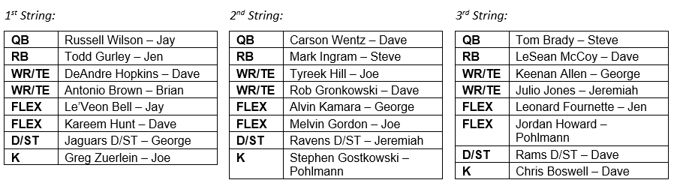

# **Next Year’s Draft Order**

Draft order for every round (excluding any 1st round comp picks)

1. Pohlmann
2. Meat
3. Joe
4. Jay
5. Jeremiah
6. Steve
7. George*
8. Brian
9. Dave**
10. World Champion Jen

* George’s 1st round pick traded to Jeremiah

** Dave’s 3rd round pick traded to George

# **2017 Adjusted Total Points (used for Non-Playoff Draft Order)**

